Student Name: __________________
Class and Section __________________
Total Points (10 pts) __________________
Due: November 5, 2010 before the class

Project: Selecting Colors

CSCI 1302 Advanced Programming Principles
Armstrong Atlantic State University

Problem Description:
Write a program that uses scroll bars to select the foreground color for a label, as shown in the following figure. Three horizontal scroll bars are used for selecting the red, green, and blue components of the color. Use a title border on the panel that holds the scroll bars.

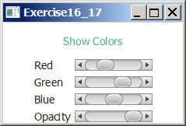

Design:
(Draw a sketch of UI)

Coding:
Name your main class Exercise16_17

Screen shots:

Submit the following items:

1. Submit a hard copy of this document.

2. Compile and Submit to LiveLab as Exercise16_17 (you must submit the program regardless whether it complete or incomplete, correct or incorrect)

3. Fill in self-evaluation:

- Is the UI created correctly?
- Is the foreground color of the string changed when a JScrollBar is moved?

